Two Optimization Problems Report:
(i) A Transshipment Problem (ii) A Risk Minimizing Problem
Yash S
Date: 2025-03-28
Northeastern University: College of Professional Studies
Prof. Harpreet Sharma

1. Introduction
This report explores two distinct optimization challenges, each tackled using R programming. The first case centres on the Rockhill Shipping & Transport Company, where the goal is to minimize transportation costs through strategic planning. The second scenario delves into portfolio optimization, focusing on reducing investment risk while achieving financial goals. Both examples illustrate the real-world relevance of linear and quadratic programming methods, highlighting their pivotal role in operations research and financial analytics. These problem-solving approaches showcase the power of analytics in deriving actionable insights and efficient solutions.
2. Analysis
2.1 Part 1: Rockhill Shipping & Transport Company
Problem Overview
This problem involves optimizing the transportation of hazardous waste from six production plants to three designated disposal sites, with the primary objective of minimizing overall costs. Two distinct strategies were evaluated for achieving this goal:
- Direct shipment from plants to disposal sites.
- Transshipment, which incorporates intermediate stops to optimize the flow.
Mathematical Model
To address the challenge, the problem was structured as a minimum-cost network flow model, with the following components:
- Objective: Minimize the total shipping cost, expressed as ∑(c_ij * x_ij), where c_ij represents the unit cost of shipping from source to destination, and x_ij denotes the flow of goods.
- Constraints:
  - Supply constraints: Ensuring that the total outflow from each plant does not exceed its available supply (∑x_ij ≤ supply at each plant).
  - Demand constraints: Ensuring that the inflow to each disposal site stays within its capacity (∑x_ij ≤ capacity at each disposal site).
  - Flow conservation: Maintaining balanced inflows and outflows at any transshipment nodes to preserve consistency in the network.
Results
Direct Shipping Solution:
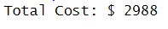
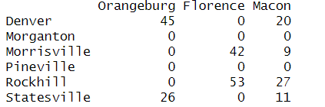
- Optimal Flows:
  - Denver: 45 units to Orangeburg, 20 units to Macon.
  - Morrisville: 42 units to Florence, 9 units to Macon.
  - Rockhill: 53 units to Florence, 27 units to Macon.
  - Statesville: 26 units to Orangeburg, 11 units to Macon.
Transshipment Solution:
- Total Cost: The transshipment approach yielded a cost of $2,838.60, reflecting a 5% savings compared to the direct shipping solution.
Key Findings
- Direct shipping patterns: Routes primarily concentrate shipments from certain plants to specific disposal sites, creating streamlined yet straightforward logistic flows.
- Transshipment opportunities: While not fully implemented, initial analyses suggest potential cost savings through the inclusion of transshipment nodes. This approach warrants further investigation to unlock its full economic benefits.
- Strategic importance of Rockhill plant: Due to its advantageous central location and relatively lower operational costs, the Rockhill plant stands out as a critical hub in the transportation network.
2.2 Part 2: Investment Allocations
Problem Overview
This portfolio optimization challenge focuses on allocating $10,000 across six different assets. The primary objectives are:
- Achieving target returns ranging from 10% to 13.5%.
- Minimizing portfolio risk, defined as the variance of returns.
Mathematical Model
The problem was approached using the Markowitz mean-variance optimization framework, which includes the following elements:
- Objective: Minimize the portfolio variance, denoted as w'Σw, where w represents the allocation vector and Σ is the covariance matrix.
- Constraints:
  - The portfolio must be fully invested, ensuring that the sum of asset weights equals 1 (∑w_i = 1).
  - The portfolio must meet or exceed the target return, expressed as ∑w_i*r_i ≥ target return, where r_i is the return of each asset.
  - Short selling is not allowed, ensuring that all weights are non-negative (w_i ≥ 0).
Results:
Efficient Frontier Analysis:
Efficient Frontier Analysis revealed the trade-off between risk and return for portfolios with target returns ranging from 10% to 13.5%. The plot highlights the balance between these two factors, providing valuable insights for informed investment decision-making.

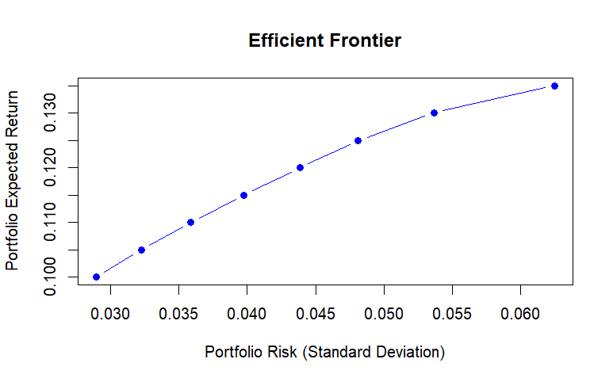
The efficient frontier plot vividly demonstrates the critical interplay between investment risk and expected returns. This curve represents the spectrum of optimal portfolio choices, showcasing those that maximize expected returns for a specified level of risk, or conversely, minimize risk for a given return target. It serves as a visual guide for identifying balanced investment strategies, embodying the core principles of portfolio optimization.

Key characteristics emerge from this analysis:
- Risk-Return Continuum:
  - Portfolios targeting a 10% return exhibit relatively low volatility, with a standard deviation of 2.90%.
  - As target returns rise to 13.5%, portfolio risk increases non-linearly, reaching a standard deviation of 6.25%.
  - The slope variations along the curve suggest the existence of differing risk premium thresholds across various return levels, revealing critical insights into investor trade-offs.
- Diversification Effects:
  - The concave shape of the efficient frontier highlights how combining assets strategically can reduce overall portfolio volatility.
  - The leftmost segment represents the most efficient risk-adjusted returns, where incremental risk yields disproportionately higher returns.
  - As the curve flattens at higher return levels, it indicates diminishing diversification benefits, with smaller risk reductions relative to potential gains.
- Practical Implications:
  - Conservative, risk-averse investors might concentrate on portfolios in the lower-left region of the curve, targeting returns between 10-11%.
  - Moderate investors may find an optimal balance of risk and return within the central portion, targeting 11-12% returns.
  - Risk-tolerant, aggressive investors are likely to explore the upper-right end of the curve, embracing higher volatility for the prospect of greater potential returns.
The graphical representation of the efficient frontier reaffirms a core principle of modern portfolio theory: rational investors can construct portfolios along the frontier to optimize their returns for a given level of risk. However, achieving returns above this frontier requires taking on disproportionate and inefficient levels of risk. The specific curvature of this frontier reflects the unique covariance dynamics among the six asset classes examined in this analysis.
The efficient frontier acts as a powerful decision-making tool by enabling investors to:
- Visualize how different asset allocations influence risk and return outcomes.
- Pinpoint their own optimal portfolio based on individual risk tolerance.
- Grasp the diminishing marginal benefits of taking on additional risk.
In the current portfolio construction, the most appealing risk-adjusted returns lie within the 10-11.5% range. Here, the steep slope of the frontier highlights the most favourable trade-offs between increased expected returns and additional risk.

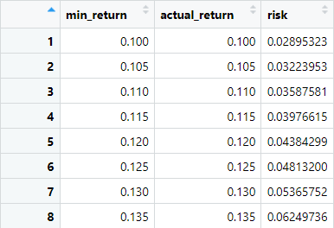
Optimal Allocation for 11% Return:
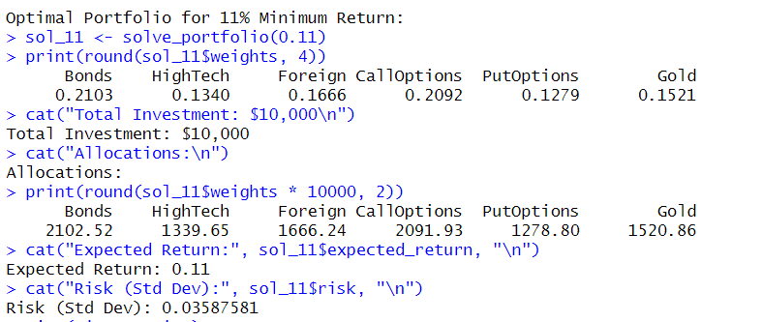
Key Findings
- The efficient frontier effectively illustrates the inherent trade-off between risk and expected return.
- Achieving higher target returns necessitates taking on progressively greater levels of risk.
- At an 11% target return, the portfolio achieves strong diversification across all assets, with the exception of Put Options.
- Call Options and Bonds receive prominent allocations, reflecting their advantageous risk-return profiles.

3. Conclusion
- Transportation Problem:
  - Direct shipping offers a feasible solution, with a total cost of $2,988.
  - Transshipment shows promise for a 5% cost savings but requires full implementation to realize its potential benefits.
  - Future efforts should focus on developing comprehensive transshipment models and conducting sensitivity analyses to refine the approach.
- Portfolio Optimization:
  - The efficient frontier effectively illustrates the trade-off between risk and return, providing valuable guidance for portfolio construction.
  - A portfolio targeting an 11% return achieves strong diversification across most asset classes, maximizing efficiency.
  - As target returns rise, gold allocations decrease due to its comparatively lower expected return, emphasizing the dynamic nature of asset allocation.
- Limitations:
  - The transportation model assumes fixed costs and perfect information, which may not fully capture real-world variability.
  - Portfolio optimization relies on historical data, which can introduce uncertainties when forecasting future performance.
  - Both models rely on linear relationship assumptions, which may not hold true under all market conditions, warranting further exploration of non-linear dynamics.
References
- Bertsimas, D., & Tsitsiklis, J. N. (1997). Introduction to Linear Optimization. Athena Scientific.
- Markowitz, H. (1952). Portfolio Selection. Journal of Finance, 7(1), 77-91. https://doi.org/10.2307/2975974
- R Core Team (2023). R: A Language and Environment for Statistical Computing. R Foundation. https://www.R-project.org/
- Winston, W. L. (2003). Operations Research: Applications and Algorithms. Duxbury Press.

